Experiment Number: 2

Problem Statement: Advanced Linux Commands

NAME: **Manomay Jamble**  ROLLNO: 49

CLASS: TY(AIDS-A) BATCH: 2

DATE OF PERFORMANCE: 01/09/2022

___________________________________________________________________________

1. Pr

Options

-3

-d

-n

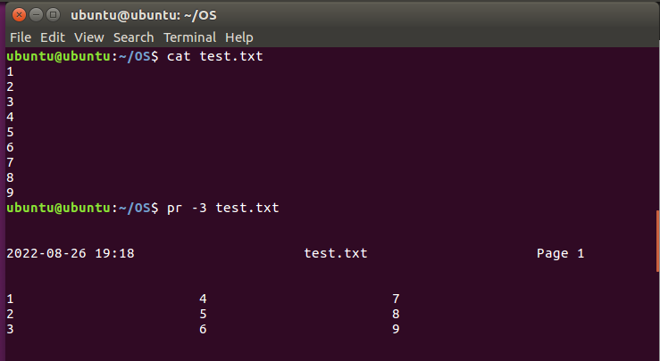

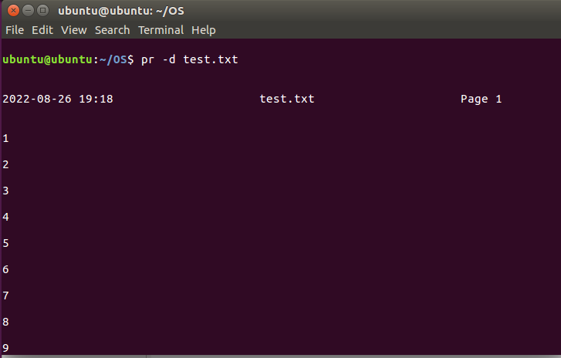

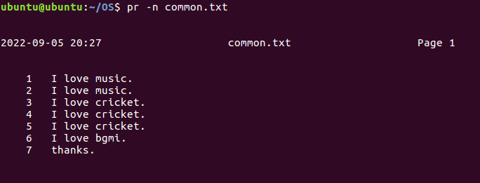

1. Head  
   Options -5  
   -c  
   -n 4  
   -q

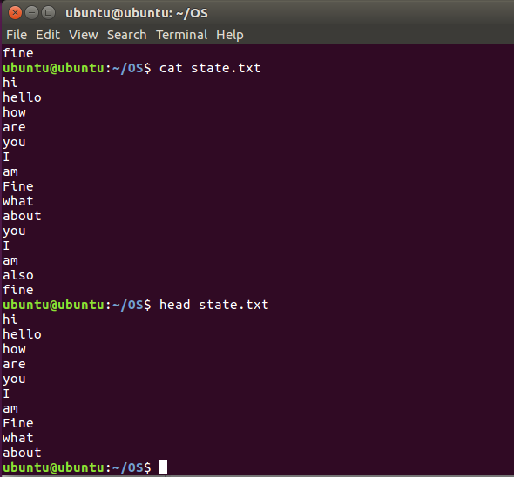

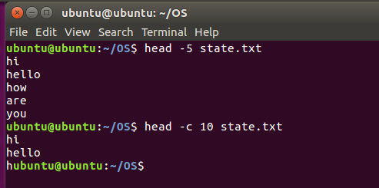

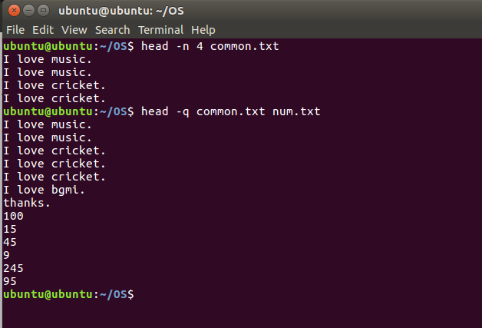

1. Tail  
   Options -5  
   -c  
   -n 5

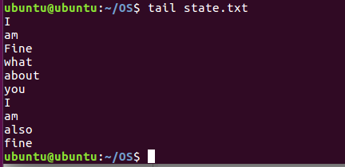

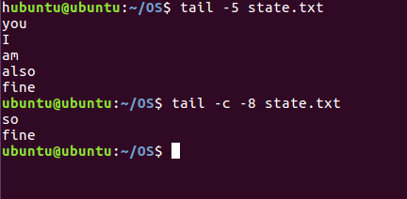

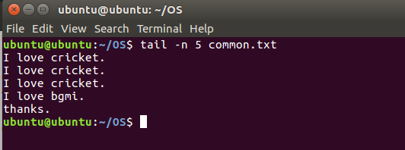

1. Cut  
   Options -b  
   -b 1-3  
   -f  
   -d

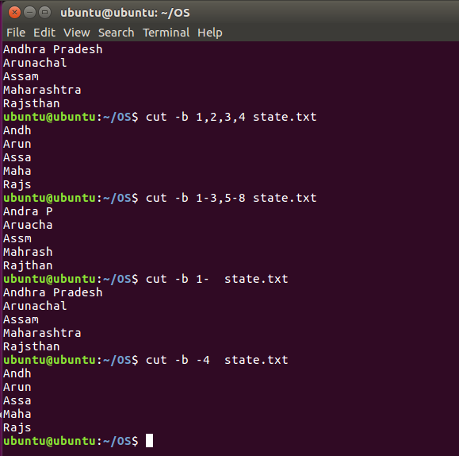

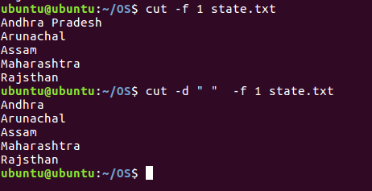

1. Paste  
   Options  
   -d  
   -d two sep  
   -s

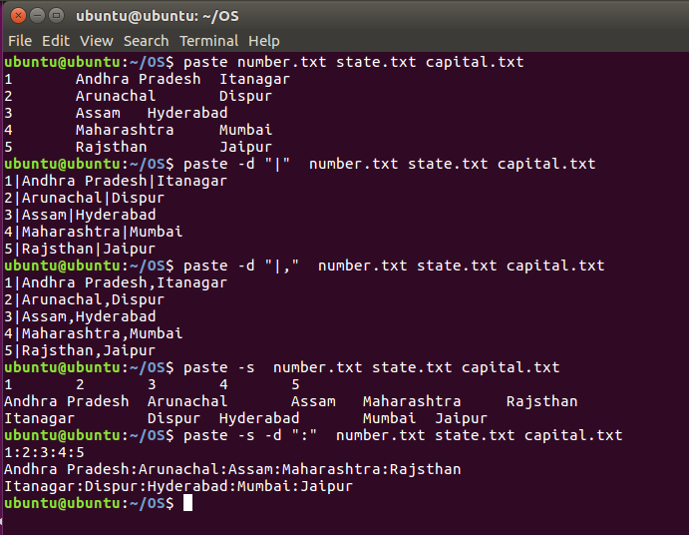

1. Sort  
   Options  
   -r  
   -n  
   -nr  
   -k  
   -c

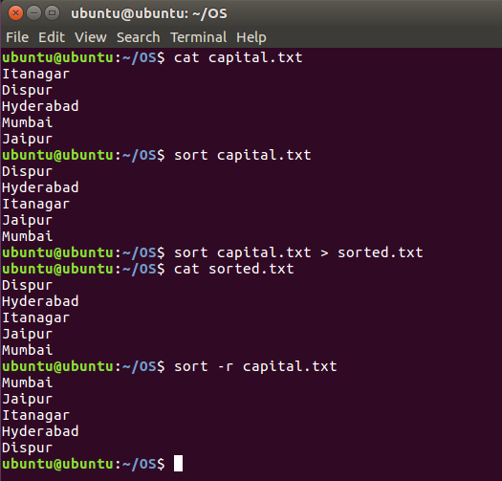

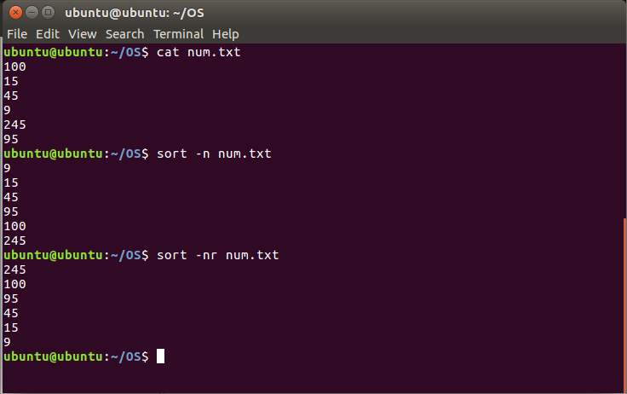

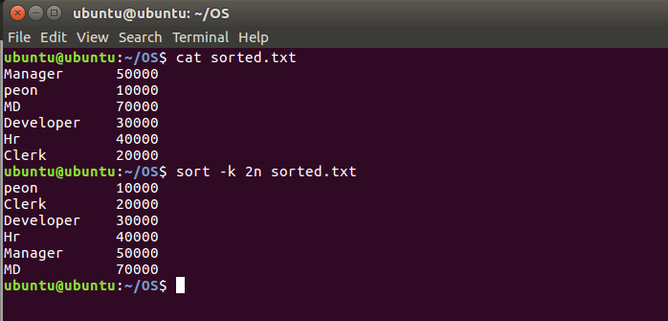

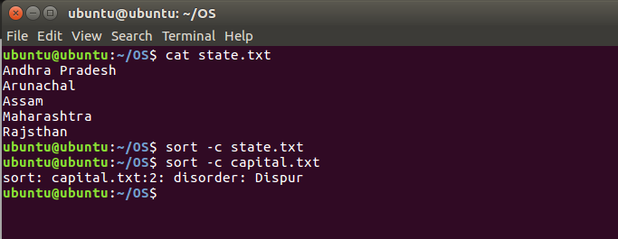

1. Tee  
   Options – -help  
   - - version  
   -a

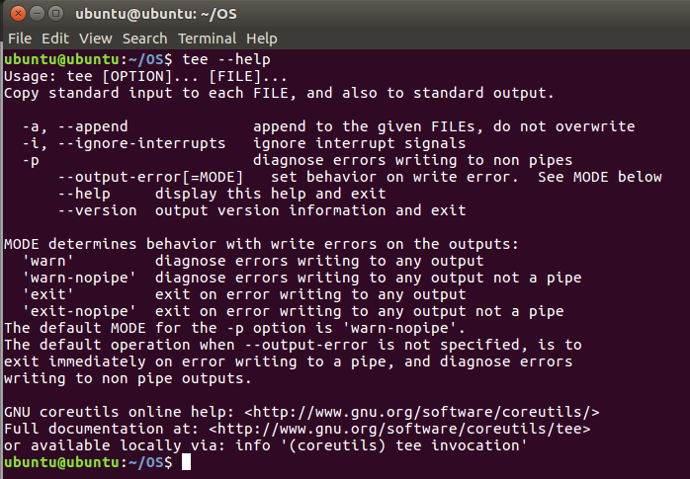

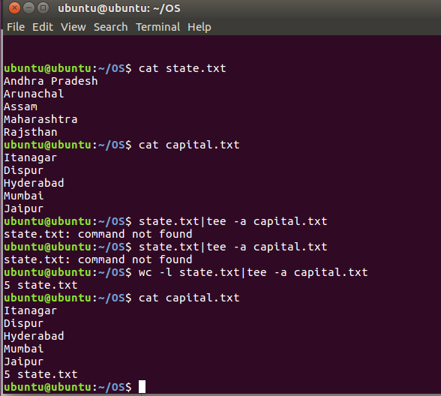

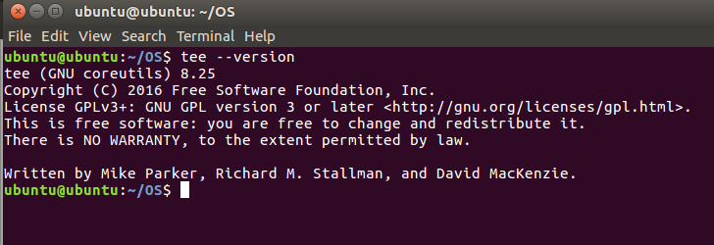

1. Tr  
   Options -d  
   -cd

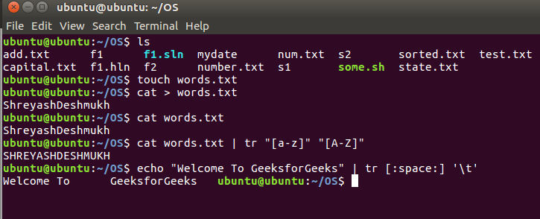

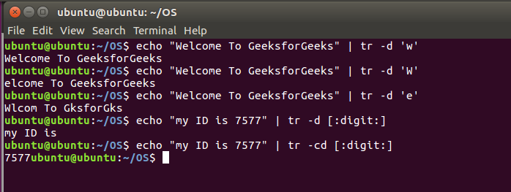

1. Grep  
   Options -i  
   -c  
   -l  
   -w  
   -o  
   -n

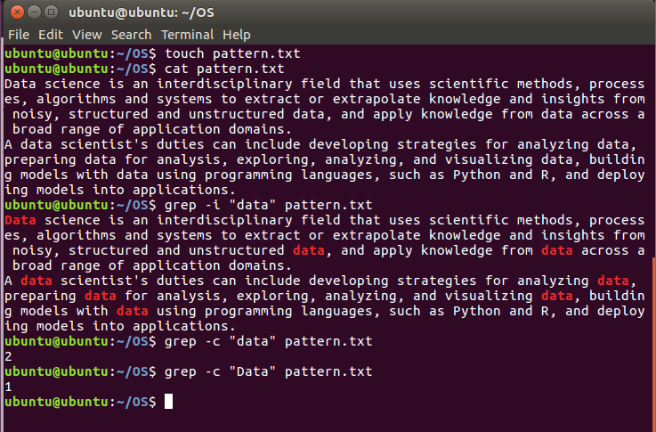

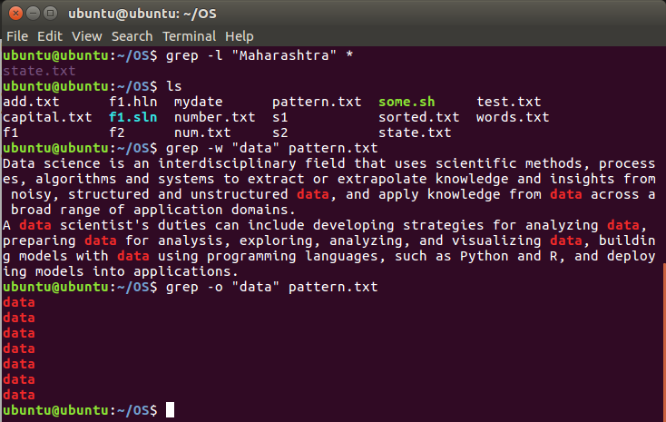

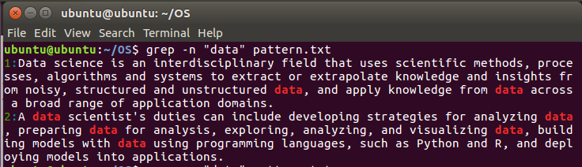

1. chmod

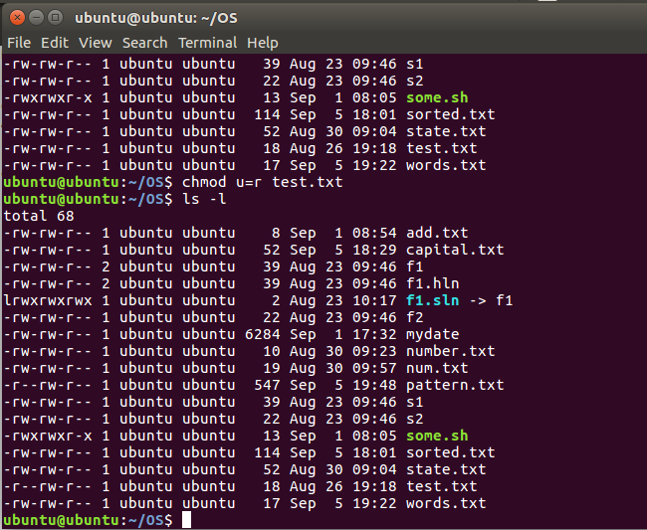

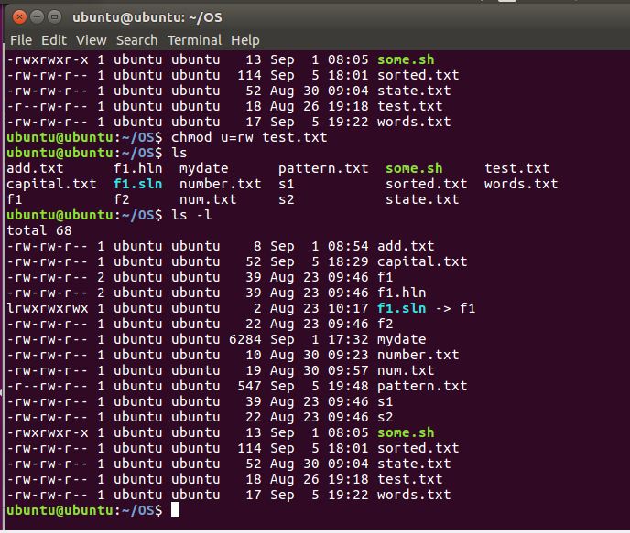

1. uniq  
   Options -c  
   -d  
   -D  
   -u  
   -i

